AWS DEVOPS ASSIGNMENT | DEPLOYMENT DOCUMENTATION
AWS DEVOPS
ASSIGNMENT
Three Deployment Configurations
Project information | Details
Submitted by | Deepanshu Tyagi
Application | Flask Backend + Express Frontend
Cloud provider | Amazon Web Services (AWS)
Region | Asia Pacific (Mumbai) — ap-south-1
Container registry | Amazon ECR
Orchestration | Amazon ECS with AWS Fargate
GitHub repository | https://github.com/codingvashu/AWS-DevOps-Assignment
ECS application URL (tested) | http://15.252.165.95:3000
1. Project Overview
The objective of this assignment is to deploy a web application consisting of a Python Flask backend and a Node.js Express frontend using three deployment approaches: both applications on one EC2 instance, applications on separate EC2 instances, and Docker containers deployed through Amazon ECR and Amazon ECS Fargate.
Objectives
Deploy Flask and Express on a single EC2 instance.
Deploy frontend and backend on separate EC2 instances with private backend communication.
Build Docker images and run them locally with Docker Compose.
Push images to Amazon ECR and deploy them on ECS Fargate.
Configure VPC networking, security groups, logs and health checks.
2. Application Components
Component | Technology | Purpose
Backend | Python Flask | API and health endpoint /health on port 5000.
Frontend | Node.js + Express | Web interface and /api/health endpoint on port 3000.
Containerization | Docker / Docker Compose | Package and run each application as a container.
Registry | Amazon ECR | Store backend and frontend container images.
Orchestration | Amazon ECS / Fargate | Run containers without managing EC2 hosts.
Networking | Amazon VPC / Security Groups | Network placement and traffic control.
Logging | Amazon CloudWatch Logs | Collect container logs.
3. Configuration 1 — Both Applications on One EC2
The Flask backend and Express frontend were deployed on one Amazon Linux 2023 EC2 instance. Nginx was configured as a reverse proxy. Browser traffic enters through HTTP port 80 and Nginx forwards it to Express on 127.0.0.1:3000. Express communicates with Flask on port 5000.
Browser → EC2 Public IP :80 → Nginx → Express :3000 → Flask :5000
Created an Amazon Linux 2023 EC2 instance in ap-south-1.
Installed Python/Flask, Node.js/Express and Nginx.
Started Flask on port 5000 and Express on port 3000.
Configured Nginx to proxy port 80 to 127.0.0.1:3000.
Kept application ports 3000 and 5000 off public ingress; browser access was through port 80.
[ INSERT SCREENSHOT: 01-single-ec2.png ]
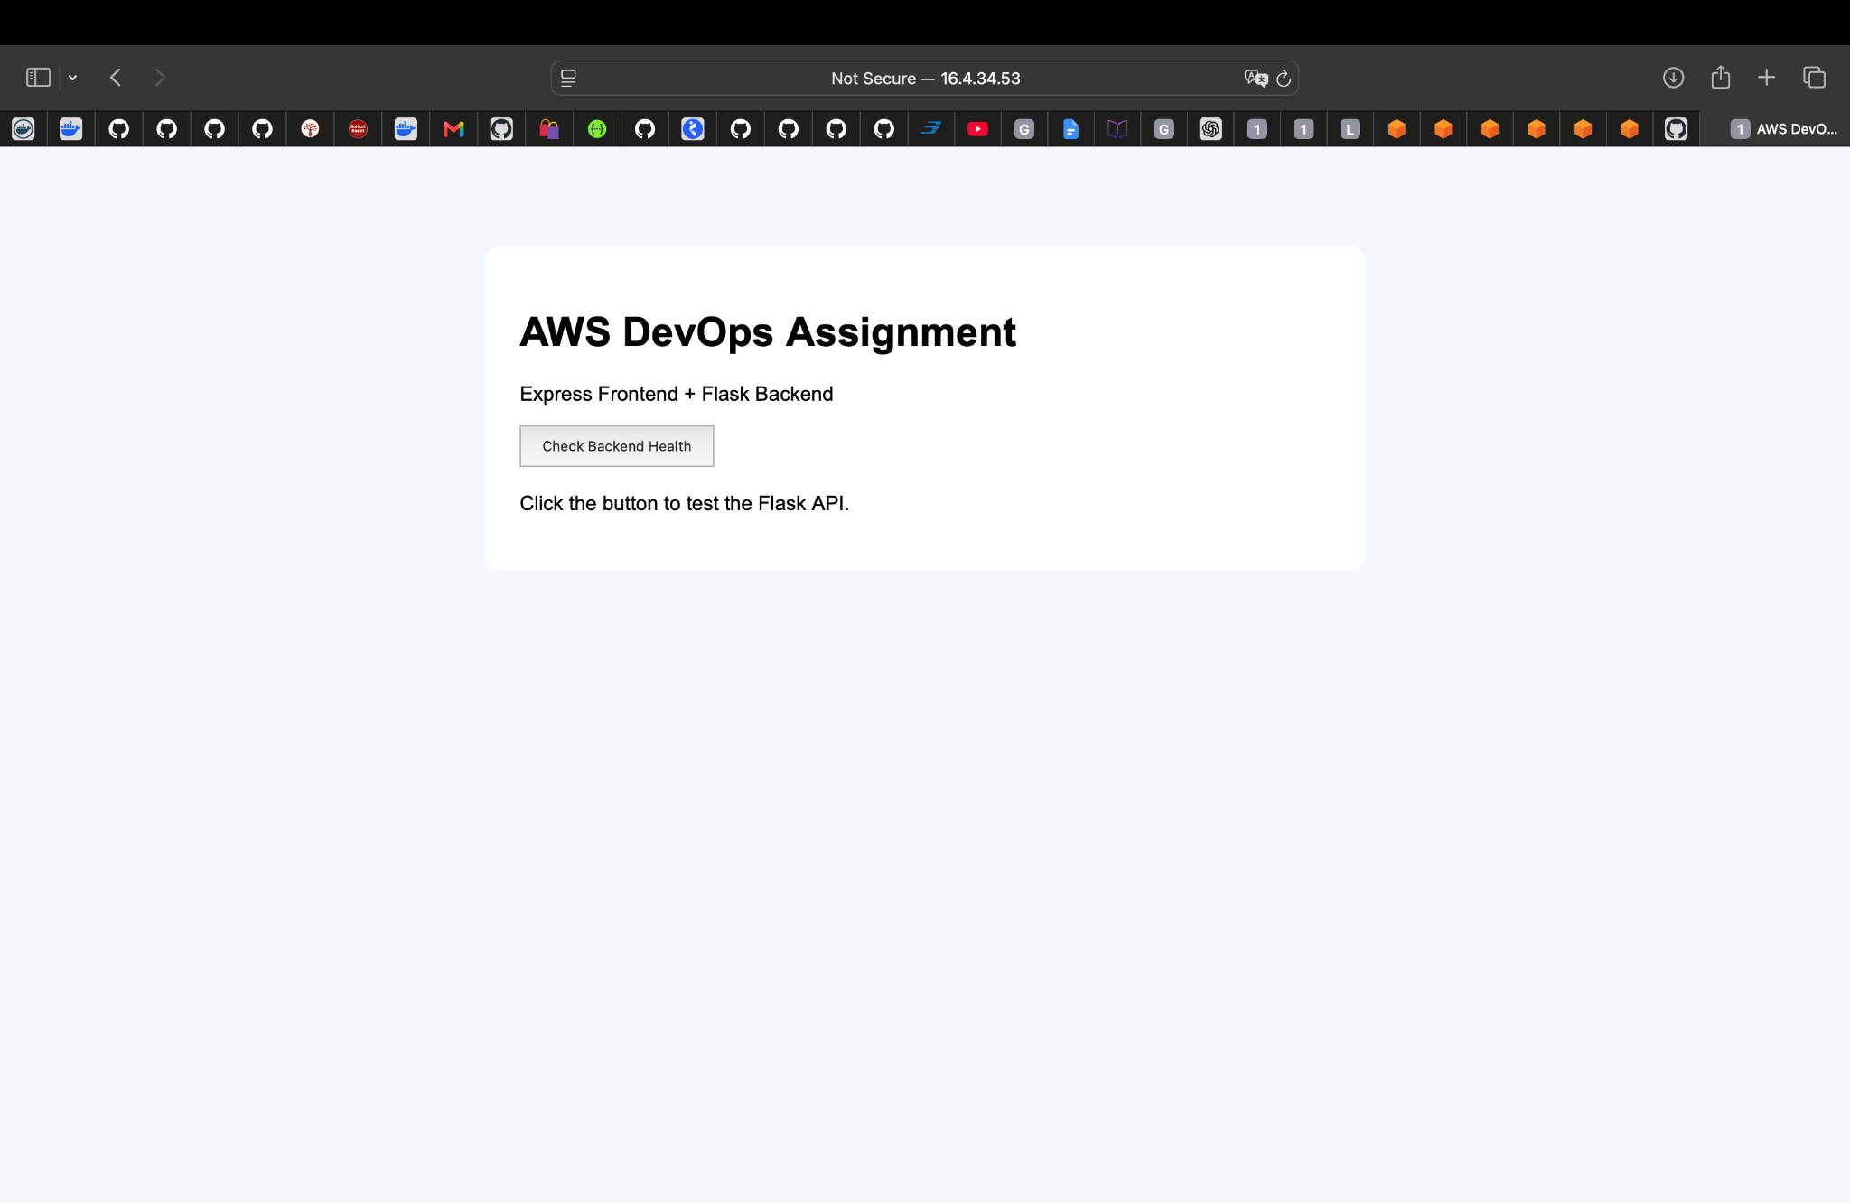
Browser screenshot showing the application deployed on the single EC2 instance.
4. Configuration 2 — Frontend and Backend on Separate EC2 Instances
The frontend and backend were deployed on two separate EC2 instances. Nginx ran on the frontend instance. The frontend connected to the backend using its private IP. The backend port was restricted to traffic from the frontend EC2 security group.
Browser → Frontend EC2 :80 → Nginx / Express :3000 → Backend EC2 private IP :5000 (Flask)
Role | Private IP | Network access
Backend EC2 | 172.31.10.43 | TCP 5000 allowed only from frontend EC2 security group.
Frontend EC2 | 172.31.14.133 | HTTP port 80 accessible to browser clients; private connection to backend.
Provisioned two EC2 instances in the same VPC.
Installed and started Flask on the backend instance.
Installed and started Express and Nginx on the frontend instance.
Configured Nginx to proxy browser requests to Express.
Restricted backend port 5000 to the frontend security group; no direct public backend access.
[ INSERT SCREENSHOT: 02-separate-ec2.png ]
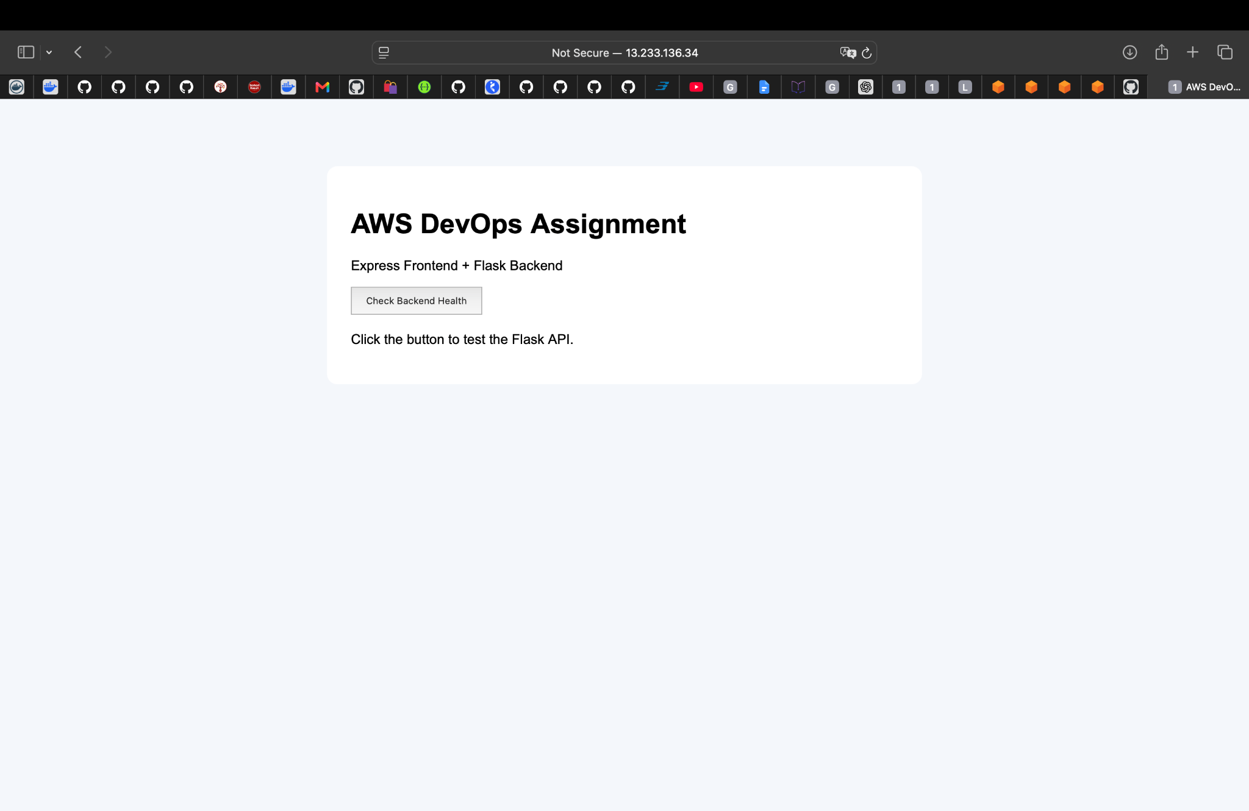
Browser screenshot showing the application served through the frontend EC2 instance.
5. Configuration 3 — Docker, ECR and ECS Fargate
The Flask and Express applications were packaged into separate Docker images. They were tested locally using Docker Compose, pushed to private Amazon ECR repositories and deployed together in one ECS Fargate task.
5.1 Local Docker Compose
The local Compose network allowed the frontend to reach the backend using the service name backend. Host port 5004 mapped to backend container port 5000; host port 3002 mapped to frontend container port 3000.
Backend: 5004:5000
Frontend: 3002:3000
Compose network: aws-network
BACKEND_URL=http://backend:5000
Backend Dockerfile
FROM python:3.11-slim
WORKDIR /app
COPY requirements.txt .
RUN pip install --no-cache-dir -r requirements.txt
COPY app.py .
EXPOSE 5000
CMD ["python", "app.py"]
Frontend Dockerfile
FROM node:20-alpine
WORKDIR /app
COPY package*.json ./
RUN npm install --omit=dev
COPY server.js .
EXPOSE 3000
CMD ["node", "server.js"]
[ INSERT SCREENSHOT: 03-docker-compose.png ]
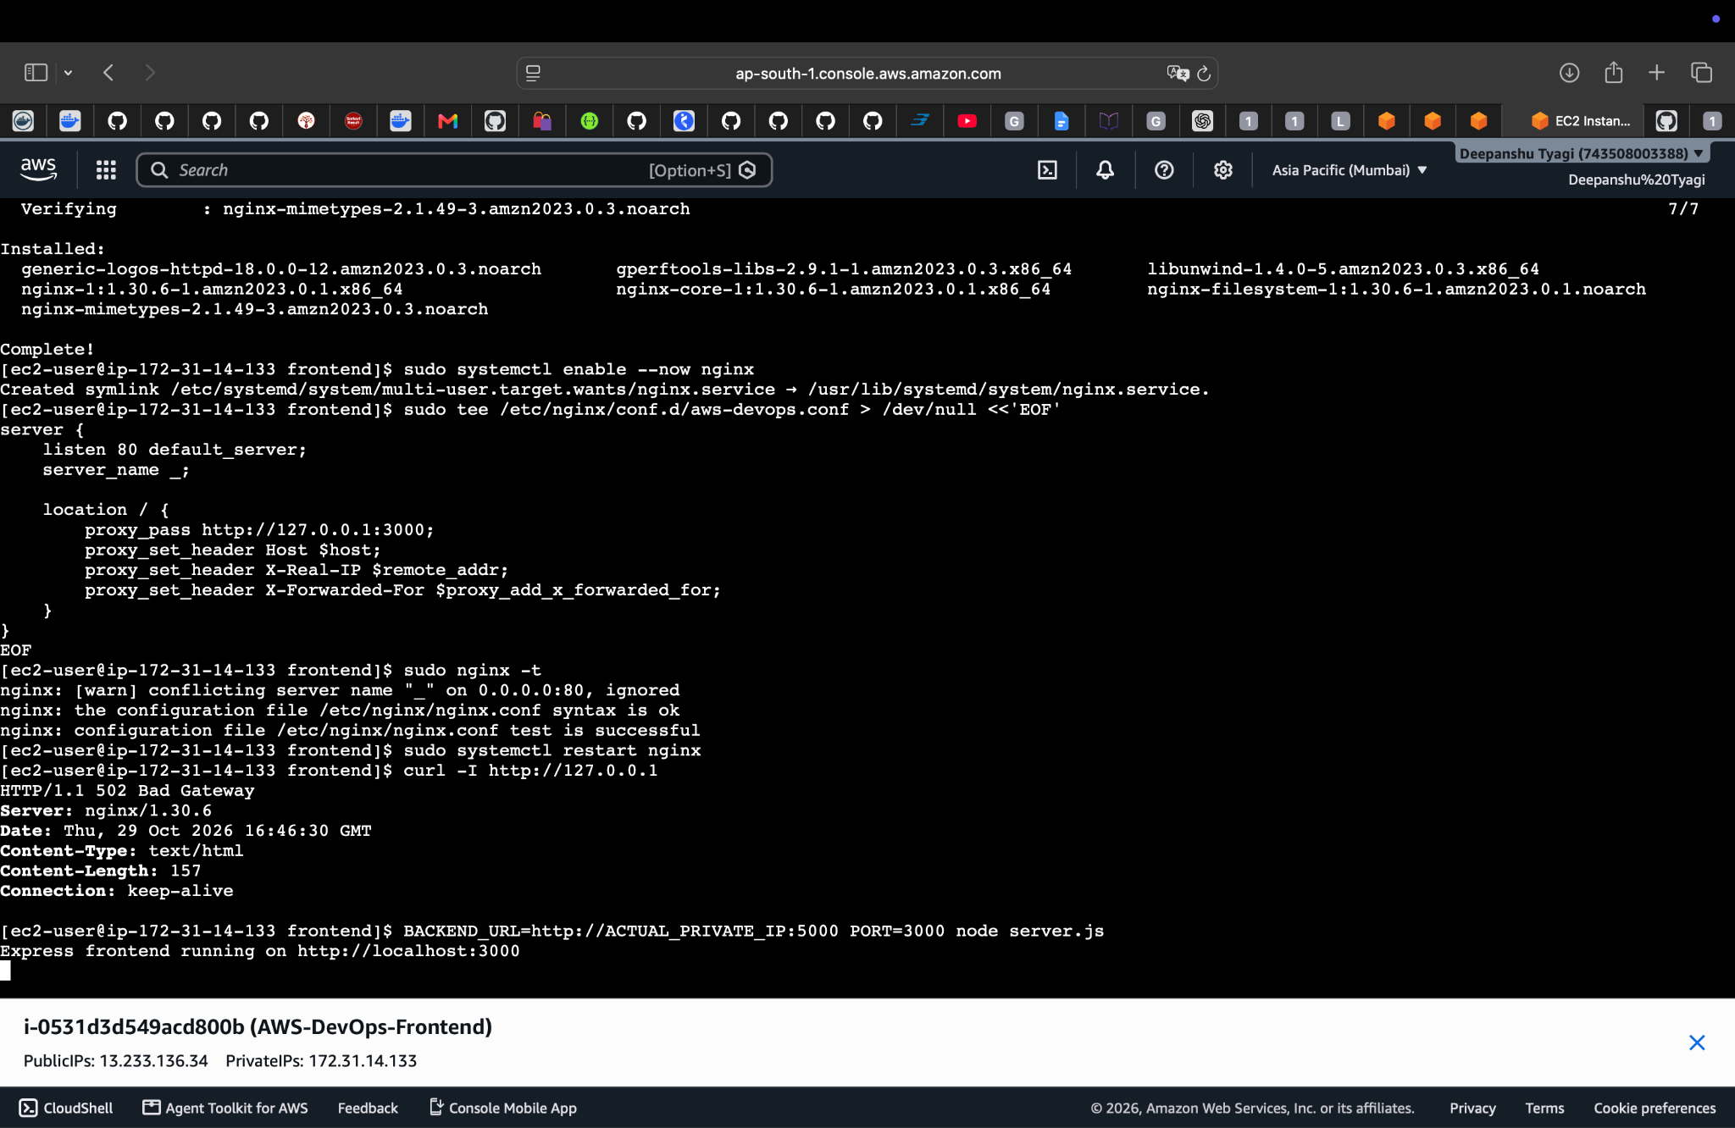
Terminal or browser screenshot proving both local containers run successfully.
5.2 Amazon ECR — Image Registry
Two private ECR repositories were created in ap-south-1. The local images were tagged with the repository URIs and pushed successfully.
Repository | Image URI
aws-devops-backend | 743508003388.dkr.ecr.ap-south-1.amazonaws.com/aws-devops-backend:latest
aws-devops-frontend | 743508003388.dkr.ecr.ap-south-1.amazonaws.com/aws-devops-frontend:latest
aws ecr get-login-password --region ap-south-1 --profile aws-console | \
docker login --username AWS --password-stdin 743508003388.dkr.ecr.ap-south-1.amazonaws.com
docker tag aws_deepanshutyagi-backend:latest 743508003388.dkr.ecr.ap-south-1.amazonaws.com/aws-devops-backend:latest
docker tag aws_deepanshutyagi-frontend:latest 743508003388.dkr.ecr.ap-south-1.amazonaws.com/aws-devops-frontend:latest
docker push 743508003388.dkr.ecr.ap-south-1.amazonaws.com/aws-devops-backend:latest
docker push 743508003388.dkr.ecr.ap-south-1.amazonaws.com/aws-devops-frontend:latest
[ INSERT SCREENSHOT: 04-ecr-repositories.png ]
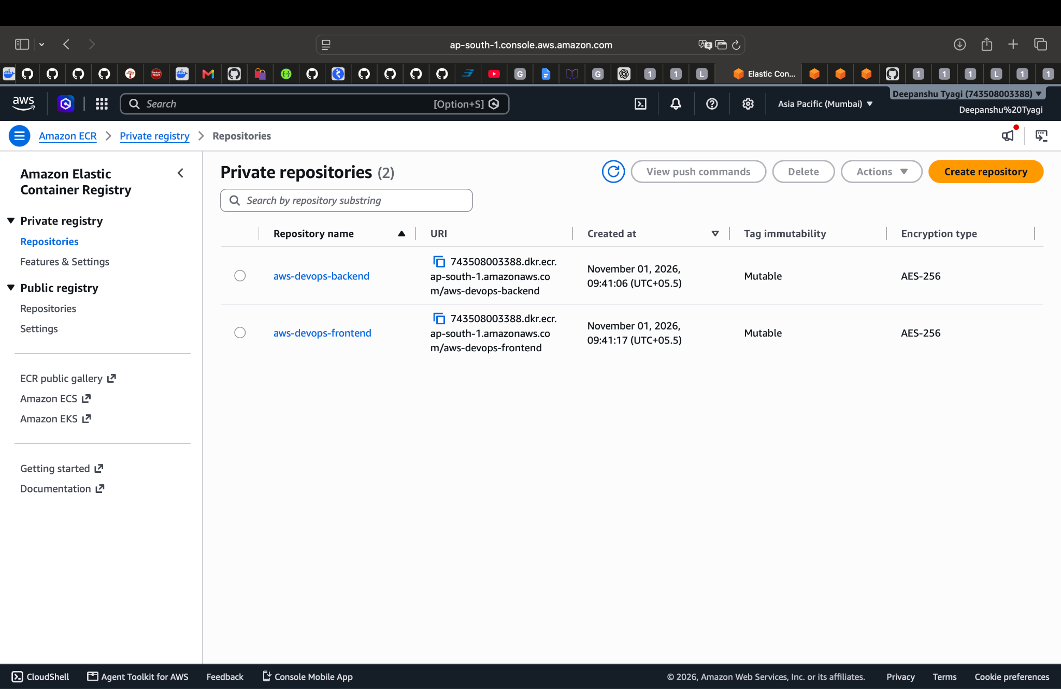
AWS Console screenshot showing both ECR repositories and pushed images.
5.3 VPC and Security Group
Resource | Configured value
AWS Region | ap-south-1 (Mumbai)
Default VPC | vpc-07e5b281b3d2cb6c8
VPC CIDR | 172.31.0.0/16
ECS Security Group | sg-0975d07bdf676c207
Inbound rule | TCP 3000 from 0.0.0.0/0
Backend port 5000 | Not opened to public internet
Task network mode | awsvpc; public IP assigned
The Fargate task used a public subnet with a public IP. Port 3000 was opened for the demonstration frontend. Port 5000 was not opened to the internet. Both containers in the same awsvpc task share the task network namespace, so the frontend used http://127.0.0.1:5000 to contact Flask.
5.4 ECS Cluster, Task Definition and Service
Setting | Value
Cluster | aws-devops-cluster
Service | aws-devops-service
Task family / revision | aws-devops-task:1
Launch type | AWS Fargate
CPU | 512 (0.5 vCPU)
Memory | 1024 MiB (1 GB)
Network mode | awsvpc
Execution role | ecsTaskExecutionRole
CloudWatch log group | /ecs/aws-devops-task
Desired task count | 1
backend container: Flask ECR image, container port 5000, CloudWatch stream prefix backend.
frontend container: Express ECR image, container port 3000, BACKEND_URL=http://127.0.0.1:5000, CloudWatch stream prefix frontend.
aws ecs create-cluster --cluster-name aws-devops-cluster --region ap-south-1 --profile aws-console
aws ecs register-task-definition --cli-input-json file://ecs-task-definition.json --region ap-south-1 --profile aws-console
aws ecs describe-services --cluster aws-devops-cluster --services aws-devops-service --region ap-south-1 --profile aws-console
aws ecs list-tasks --cluster aws-devops-cluster --service-name aws-devops-service --region ap-south-1 --profile aws-console
[ INSERT SCREENSHOT: 05-ecs-cluster.png ]
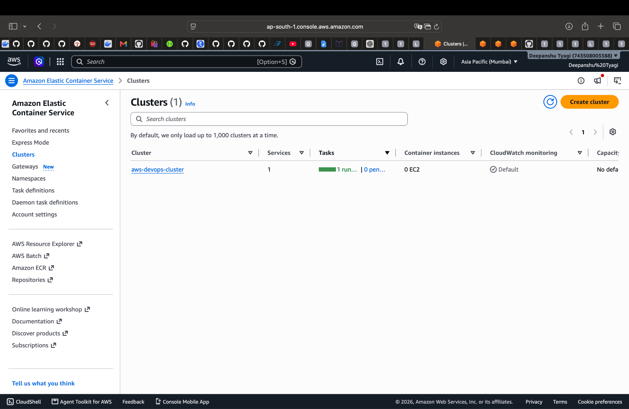
ECS cluster and active service screenshot.

[ INSERT SCREENSHOT: 06-ecs-running-task.png ]
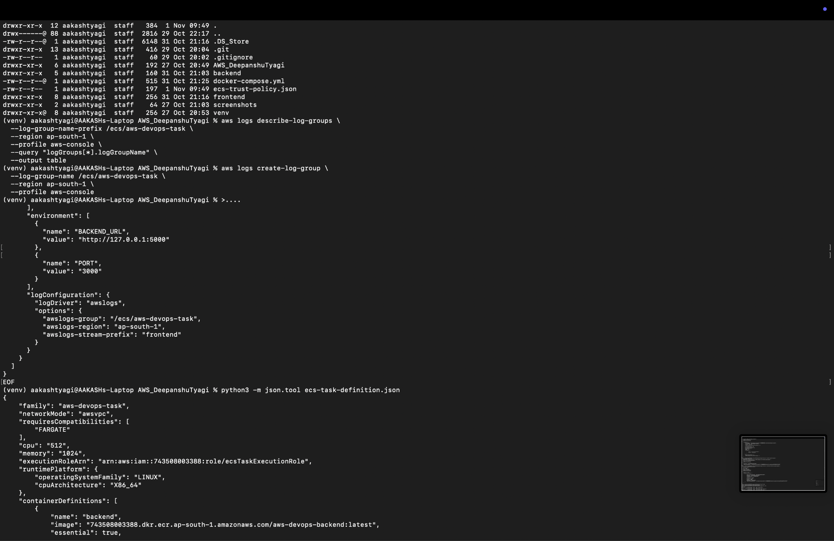
ECS task details showing RUNNING status and Fargate launch type.
6. Deployment Verification and Test Results
The ECS service deployment completed successfully. The service reported one desired task, one running task, zero pending tasks and rollout state COMPLETED.
Verification | Observed result | Status
ECS service | ACTIVE | PASS
Desired / running task count | 1 / 1 | PASS
Pending task count | 0 | PASS
Deployment rollout | COMPLETED | PASS
Public IPv4 | 15.252.165.95 | ASSIGNED
Frontend API health check | HTTP/1.1 200 OK | PASS
Response body | {"status":"healthy"} | PASS
Live application
http://15.252.165.95:3000
Health-check command:
curl -i http://15.252.165.95:3000/api/health
Observed response:
HTTP/1.1 200 OK
Content-Type: application/json; charset=utf-8
{"status":"healthy"}
The successful response confirms that the Express frontend endpoint returned a healthy response after contacting the Flask backend health endpoint.
[ INSERT SCREENSHOT: 07-ecs-website.png ]
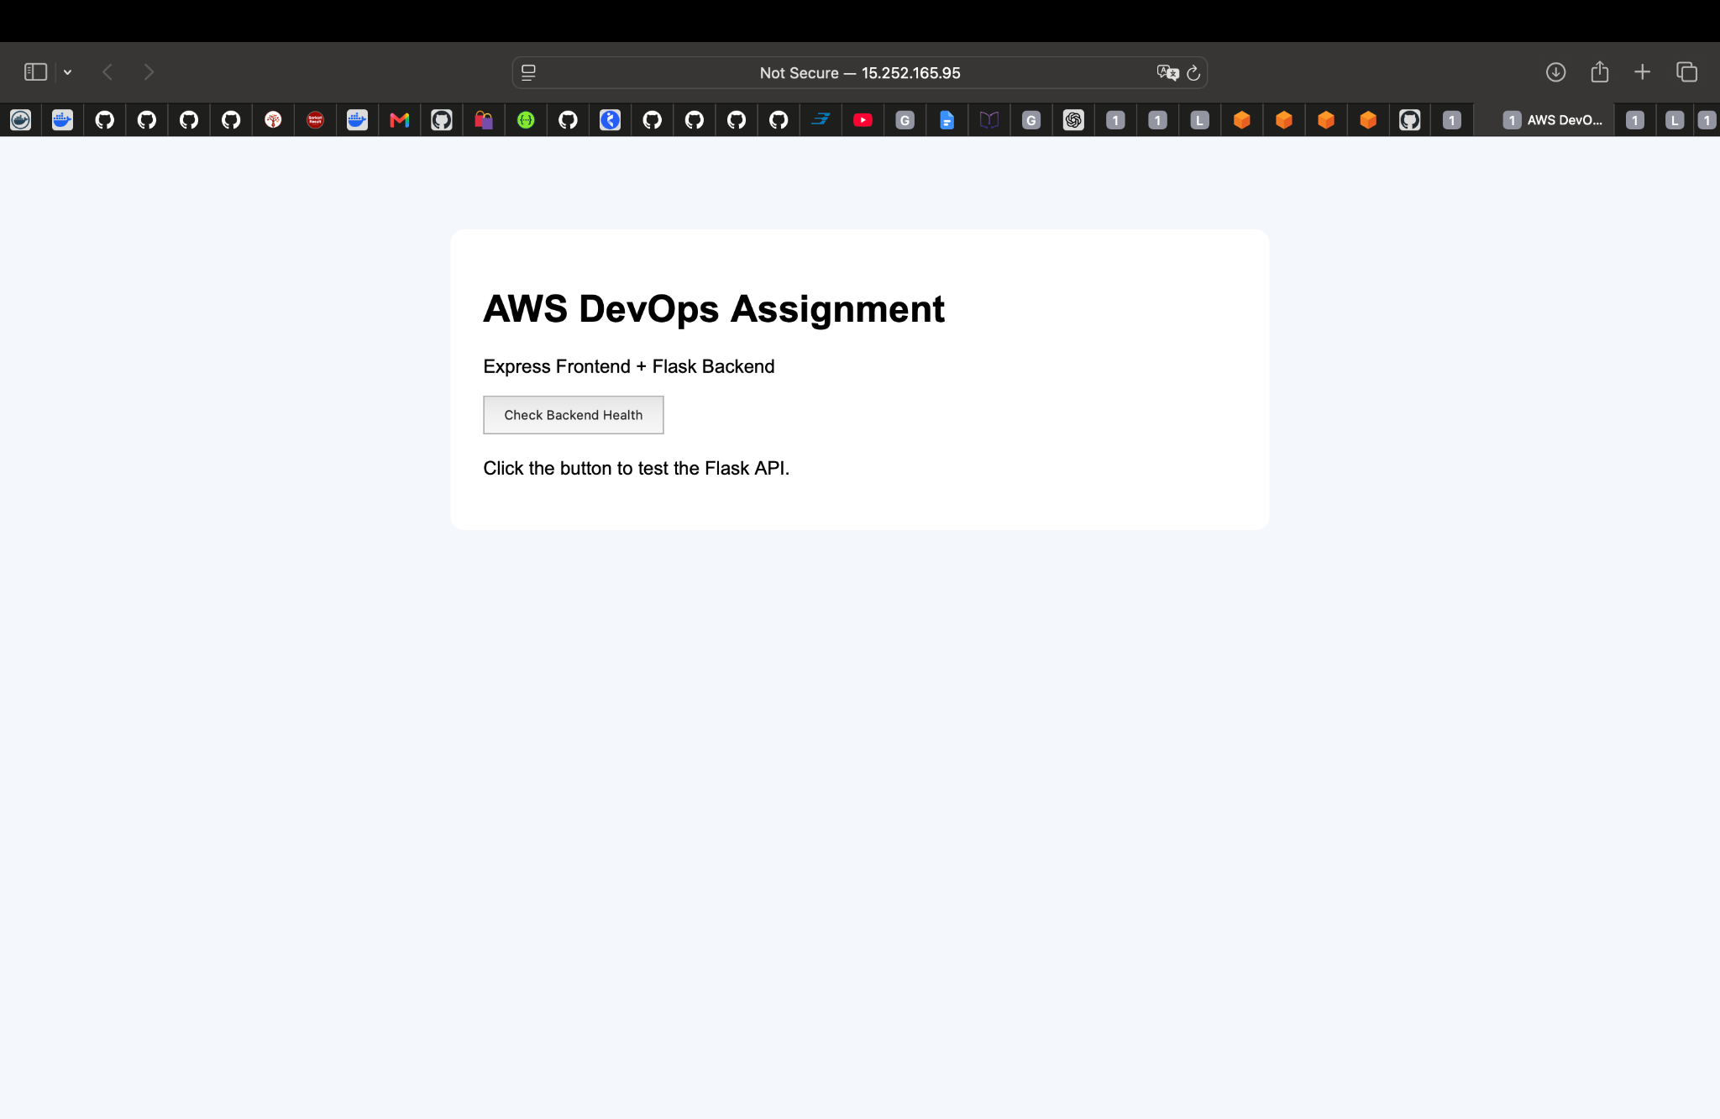
Browser screenshot of the live ECS Fargate application.

[ INSERT SCREENSHOT: 08-backend-health.png ]
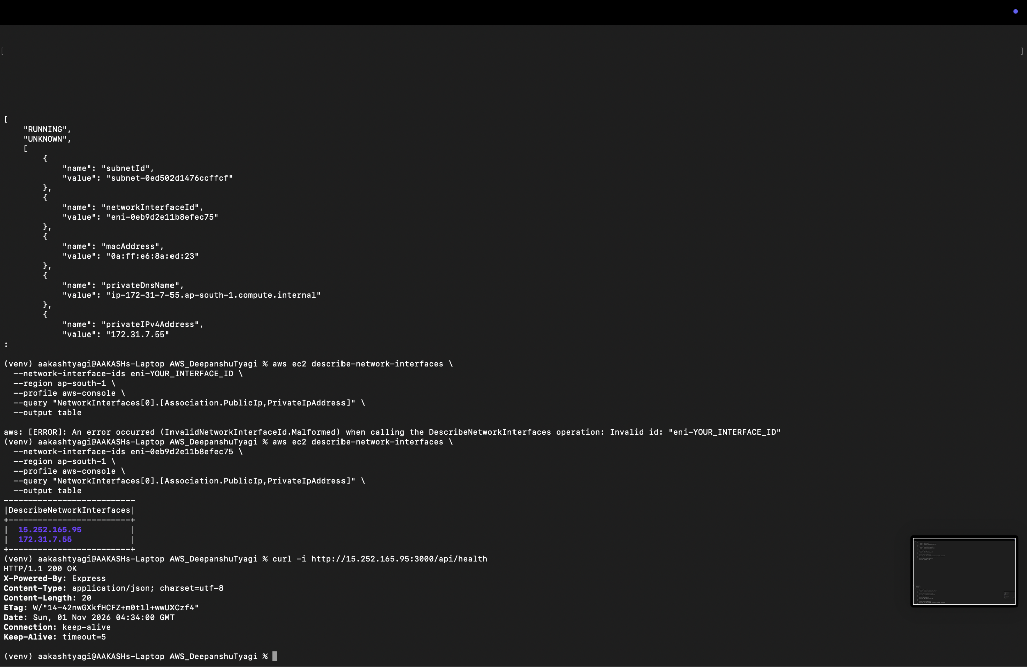
Terminal screenshot showing curl output with HTTP 200 OK and healthy JSON.
7. Comparison of the Three Configurations
Criteria | Single EC2 | Separate EC2s | Docker + ECS Fargate
Compute | One EC2 | Two EC2 instances | Managed Fargate task
Separation | Same host | Separate hosts | Separate containers
Networking | Nginx proxy | Private backend connection | VPC + awsvpc networking
Scaling | Mostly manual | Per-instance | ECS service desired count / scaling
Operations | Manage OS and services | Manage two hosts | Manage images and task definitions
Suitable for | Simple deployment | Host-level separation | Cloud-native containers
8. Challenges and Resolutions
Challenge | Resolution
Python dependency version issue | Adjusted the click dependency pin to click==8.1.8.
Local vs ECS container networking | Used Compose DNS http://backend:5000 locally and http://127.0.0.1:5000 inside the shared ECS task.
Missing ECS execution role | Created ecsTaskExecutionRole with ECS task trust policy and attached AmazonECSTaskExecutionRolePolicy.
Expose frontend without exposing backend | Allowed inbound TCP 3000 only; did not add public ingress for port 5000.
Container logs | Created /ecs/aws-devops-task and configured awslogs for both containers.
9. Security and Cost Considerations
Port 3000 is open to 0.0.0.0/0 for this demonstration. For production, use HTTPS and restrict inbound access appropriately, typically through a load balancer.
The Flask development server is suitable for this learning exercise only. Use a production WSGI server such as Gunicorn for production.
Never commit AWS access keys, secret keys, session tokens or .env secrets to GitHub.
Fargate runtime, public IPv4, ECR image storage, CloudWatch logs and data transfer may incur AWS charges.
After capturing evidence, scale the ECS service to zero or delete it if the live deployment is no longer required.
10. Cleanup After Evidence Collection
After all required screenshots and tests are saved, scale the service to zero to stop the Fargate task. If the assignment no longer needs the service, delete it. Check dependencies before removing other resources.
aws ecs update-service --cluster aws-devops-cluster --service aws-devops-service --desired-count 0 --region ap-south-1 --profile aws-console
# After the task has stopped, delete the service if no longer needed
aws ecs delete-service --cluster aws-devops-cluster --service aws-devops-service --force --region ap-south-1 --profile aws-console
Only remove the ECS cluster, ECR repositories, CloudWatch log group and security group if they are no longer needed. Do not terminate EC2 instances used by other projects or assignments.
11. Conclusion
This assignment demonstrated three ways to deploy a Flask backend and Express frontend: a single EC2 instance with Nginx, separate EC2 instances with private backend communication, and Docker containers deployed on Amazon ECS Fargate using images stored in Amazon ECR. The final ECS deployment was verified with a running task and a successful HTTP 200 health-check response. The work provided practical experience with Linux hosting, reverse proxies, Docker, Docker Compose, ECR, IAM roles, VPC security groups, ECS task definitions, Fargate networking and CloudWatch logging.
12. Final Submission Checklist
Insert the eight screenshots in the marked places in this document.
Confirm the GitHub repository contains the source code and Docker/AWS configuration files.
Do not upload credentials, private keys, session tokens or secret .env values.
Save the final Word document and export a PDF if required by the instructor.
Create a ZIP containing the project folder, final documentation and screenshots.

